 Minimize Docker Image Size for Enhanced Containerization.

Create a resource group

Create a virtual machine

Connect the server with VM IP address to PowerShell

Install docker server with commands has given below documentation on install docker on ubuntu

Next :

Search for image



Create a image dockerhub you can choose the site to create image

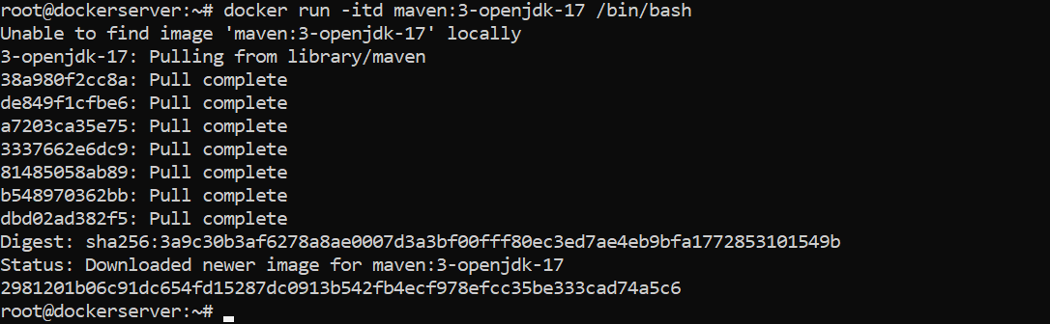

Successful pulled image

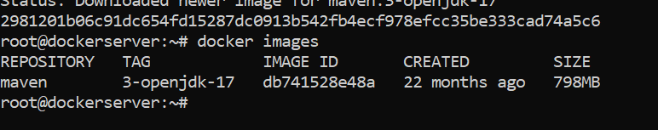

Next open visual code to create staging to reduce image size

Multi stage:

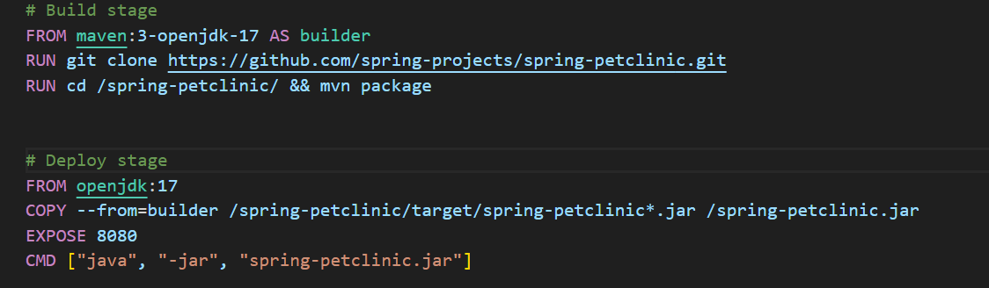

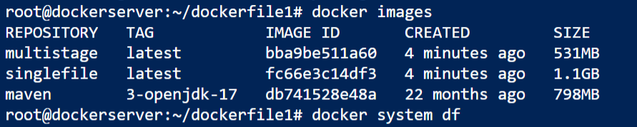image size has reduce using multistagging method